
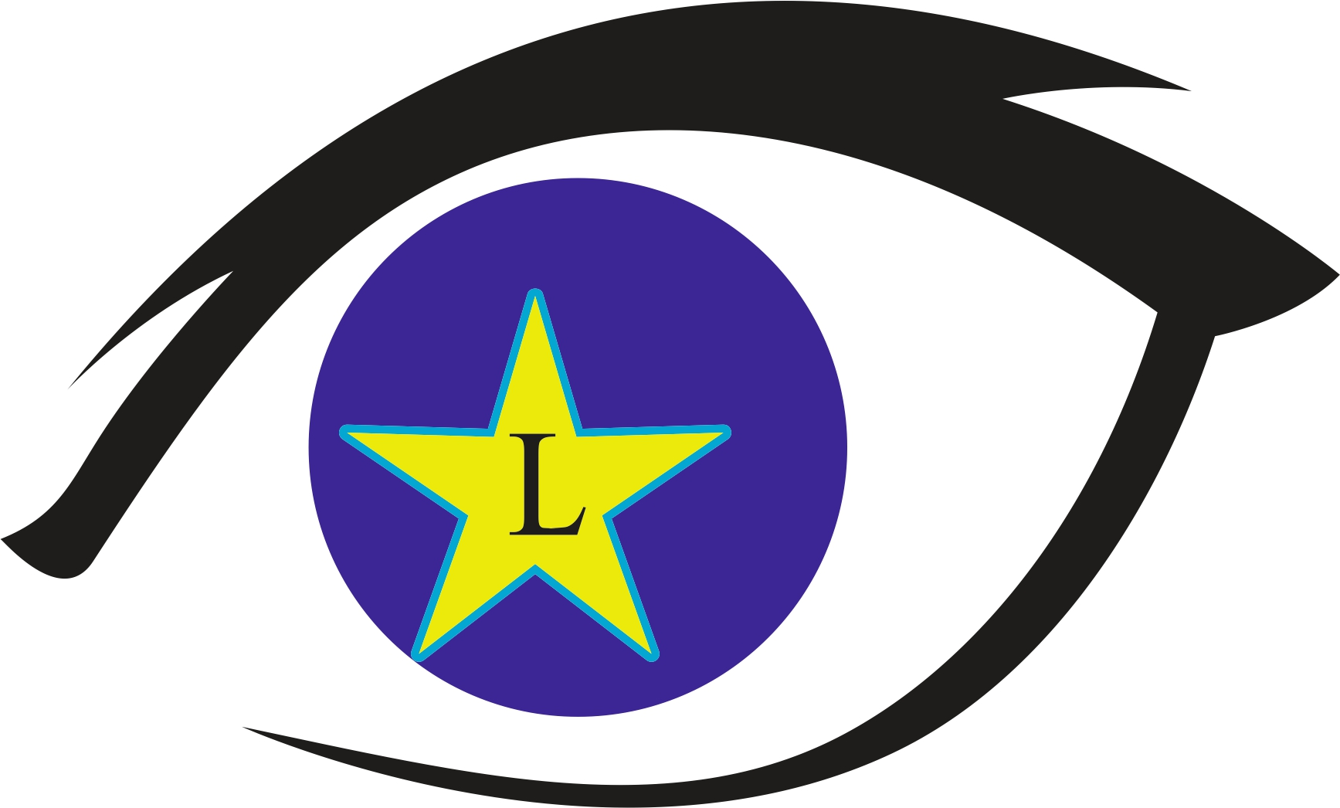
Mobile Clinic Application for Lions Eyeglasses
I request help from the Lions Sight & Tissue Foundation

To obtain a vision examination and glasses, if required, for my child
(All blanks to double lines MUST be filled out to be eligible)

Student’s Name: ___________________________________Social Security Number: ___________________

Address: ______________________________________ Apt. #: ____ City: ______________ Zip: _________

Home Phone: _____________________ Date of Birth: ________________ Age: _____Sex: ___ Grade: _____

The Student will be having a comprehensive eye exam by an eye Doctor. Drops may be put in their eyes to dilate the pupil so that the Doctor can see the inside part of the eye. These drops will not harm the eye or the eyesight, even though the pupil will be larger than normal. The pupil will gradually return to its normal size. The vision may be blurry and the eyes sensitive to bright light until the pupil returns to its normal size. All of this is perfectly normal. The eye exam can detect problems inside the eye. Your signature gives permission for your child to receive these drops. By my signature, I also give the LS&TF and its partner’s permission to take pictures of my child.

Qualification Guidelines:
- The recipient, student or adult, must not have Insurance / Medicaid that will pay for his/her glasses.
- The recipient’s family income must fall below poverty level (3) three times.

Total Number of Household Members: _______.

Total Yearly Household Income: $ _____________.

I swear or affirm that the above information is true, that we meet the above conditions and that me, or my child does qualify for the free exam and glasses. Additionally, I am hereby authorizing FULL disclosure of the results of my or my child’s vision examination, provided by the Lions Sight & Tissue Foundation and/or its partners. This information may be shared only with the following individuals: his/her School Nurse, Essilor. or another LSTF program partner. I understand that I may, at any time revoke this authorization in writing, however, by doing so I understand that I will forfeit any services provided by the Lions Sight & Tissue Foundation and/or its partners. I understand if an unauthorized disclosure is made, I may file a formal complaint with the United States Department of Health and Human Services.
A $10.00 DONATION IS ASKED PER APPLICATION BUT IT IS NOT REQUIRED. (CASH ONLY, NO CHECKS)

________________________________________________________Parent/Guardian Signature

________________________________________________________ Printed Name

FOR SCHOOL NURSE USE ONLY (REQUIRED)

Failed Vision Screening TWICE on these Dates: 1st ______________________ 2nd _____________________

Acuity Test Results for the above dates R:__________ L:__________ R:__________ L:__________

Symptoms or Complaints: _____________________________School Nurse: ___________________________

Name of School: __________________________________

Nurses Signature: ____________________________________________________
Aplicacion para Anteojos de la Clinica Mobil
Yo Solicito ayuda del Club de Lions del Districto 2-X1

Para obtener una examen de la vista y anteojos, para mi nino/a
(favor de llenar todas las lineas)

Nombre de estudiante: ______________________________________ # de Seguro Social: ________________

Domicilo: ___________________________________ # de Apt____ Ciudad: ______________ Zip: _________

# de telefono: ________________ fecha de nacimiento : _______________ edad: _____sexo: ___ greid: _____

Los estudiantes tendran un examen de la vista llevado a cabo por un medico do los ojos. Unas gotas seran puestas en los
Ojos para dilator la pupila para que el medico pueda ver dentro del ojo. Estas gotas no haran dano al ojo o la vista, aunque la pupila sera mas grande de lo normal. La pupila regresara gradualmente su tamano noprmal. La viosta sera borrosa y los ojos seran sensnlies a la luz brillante hasta que la pupila regrese a su tamano normal. Todo esto es perfectamente normal. Este examen de los ojos pueede detector problemsas detro el ojo. Su firma dara permiso para que se hijo/a reciba estas gotas. Con mi firme, tamblen doy permiso a la LS&TF y a sus socios para tomar fotos de mi hijo/a.

Gui de Calificaciones:
- El recipiente, estudiante o adulto no puede tener seguro medico o Medicaid que cubra el pago de los anteojos.
- El salario del recipient debe de estar debajo del nivel federal de la pobreza (3 veces).

# Total de miembros de la casa: ______________

# Ingreso total al ano: $ _____________

Yo afirmo que la informacion es verdad, que nosotros cumplimos con las condiciones y que yo o mi nino/a calificamos para tener anteojos o examenes gratis. Tambien yo autorizo revelacion total del examen proveido por Lions Sight & Tissue Foundation. Esta informacion puede ser compartida solamente con la enfermera de la escuela. Essilor or another LSTF program partner, Yo entiendo que yo puedo rechazar esta autorizacion en escrito, pero con hacer eso, yo entiendo que yo pierdo todos los derechos de servicios proveidos por el Club de Lions Sight & Tissue Foundation y sus patrocinadores. Yo entiendo que si una revelacion no es autorizada, Yo puedo presentar una demanda con los Servicios de Salud y Humanos de los Estadso Unidos.
Se pida una donacion de $10.00 por aplicacion, pero no es requerido.
________________________________________________________ Guardiante/Padre firma

________________________________________________________ Letra de molde

FOR SCHOOL NURSE USE ONLY (REQUIRED)

Failed Vision Screening TWICE on these Dates: 1st ______________________ 2nd _____________________

Acuity Test Results for the above dates R:__________ L:__________ R:__________ L:__________

Symptoms or Complaints: _____________________________School Nurse: ___________________________

Name of School: __________________________________

Nurses Signature: __________________________________

